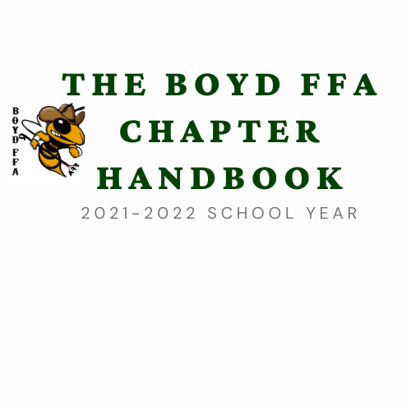

**FFA HANDBOOK 2024-2025**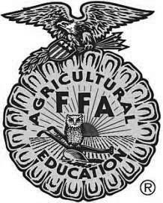

**Table of Contents**

* Welcome
* Calendar of Events
* Chapter Officers
* FFA Membership
* FFA Creed, Motto, Mission Statement, Opening Ceremony
* Boyd Area Buyers Association
* Did You Know? Agriculture Facts
* Events
* Supervised Agricultural Experience or SAE
* The FFA Jacket
* Official Dress Guidelines
* Awards Program
* Scholarship Opportunities
* General Permission Form and Acknowledgment of Handbook Form
* Overnight Travel Form

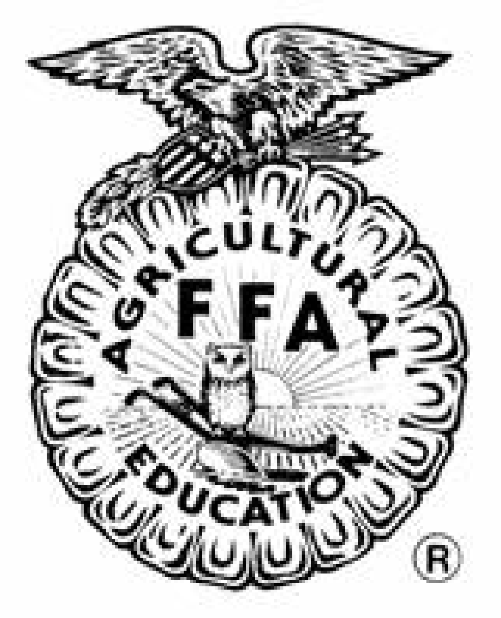

***Dear Students and Parents,***

Welcome to the 2024-2025 school year and the Boyd FFA Chapter. We are excited to see all of our returning students and want to extend a warm welcome to all new students in our program. We hope that you will take advantage of every opportunity this program has to offer you during your FFA membership.

Agricultural science courses and the FFA organization go hand-in-hand to create a complete learning experience for every student. As the FFA motto states, “Learning to do, Doing to learn, Living to serve, and Earning to live,” knowledge gained in ag science classes is demonstrated by FFA members.

As a member of the Boyd FFA Chapter you are also a part of one of the largest youth organizations in the United States, the National FFA Organization. FFA is not only a club, but a part of your agricultural education experience.

There are numerous opportunities to appeal to FFA members with a variety of interests. It is our hope that you will become an active member of Boyd FFA and continue to be involved in the ag program during your high school years.

We have a full slate of activities to participate in and look forward to seeing you and your family often. If you have any questions, please call, e-mail, or come by the ag department. We would love to visit with you and explore your interests in our program.

**Sincerely,**

**Scott Rawlings**

**Kayla Horton**

**Stephanie McGilvray**

**Full Calendar of Events available online at** [**www.boyd.ffanow.org**](http://www.boyd.ffanow.org) **or** [**www.boydisd.net**](http://www.boydisd.net) **> HS Page/ Organizations/ FFA**

**Contact Us:**

**Mr Rawlings –** [**srawlings@boydisd.net**](mailto:srawlings@boydisd.net)

**Mrs Horton–** [**khorton@boydisd.net**](mailto:khorton@boydisd.net)

**Mrs. McGilvray -** [**smcgilvray@boydisd.net**](mailto:smcgilvray@boydisd.net)

**Mrs. Richardson -** [**crichardson@boydisd.net**](mailto:crichardson@boydisd.net)

**Boyd ISD Agricultural Science Department**

700 Knox Avenue

P.O. Box 92308

Boyd, TX 76023

Office phone: 940.433.9580

Fax: 940.433.9593

**WEBSITE**

**www.boydisd.net > Students and Families > CTE > Career Technical Student Organizations > Future Farmers of America**

[**https://boydisd.net/student-families/programs-and-student-services/cte/agriculture/ffa/**](https://boydisd.net/student-families/programs-and-student-services/cte/agriculture/ffa/)

**Boyd FFA Now Website**

[www.boyd.ffanow.net](http://www.boyd.ffanow.net)

**Cell Phone Policy:**

**We request all personal contact through cell phones is done by parents and for urgent reasons only.  Cell phones are our personal property and any fees incurred from calls/texting are paid for out of the instructors pocket.  Any message left on the department voicemail or with the high school receptionist will be promptly returned. Thank you for understanding and cooperation.**

*Boyd ISD Career and Technology Programs are open to all students without regard to race, color, national origin, gender, handicapping condition, or limited English proficiency. This handbook can be made available in Spanish upon request.*

*The Boyd ISD Board of Trustees and the administrative staff fully concur with the policies and procedures as stated. Further, there is a firm commitment to comply with the provisions of the following laws: Section 504-Rehabilitation Act of 1973, as amended; and Public Law 105-17, Individuals with Disabilities Act (IDEA) Amendments of 1997.*

**FFA Membership**

Our chapter is affiliated with the State and National FFA Organizations, therefore every student enrolled in agriculture science taught at Boyd ISD is an FFA member!

Active FFA members may choose to pay their local dues of $30. All members who pay local dues will receive a free chapter t-shirt and will have their District and Area Dues paid to be locally active members for competitive participation.

**Benefits of FFA Membership include…**

* One year of membership
* FFA New Horizons Magazine subscription
* Meal at the FFA Banquet and Welcome Back BBQ
* 20% Discount at La Quinta Inns and Suites
* Boyd FFA t-shirt **(with payment of local dues)**
* Official FFA Membership card
* The opportunity to develop premier leadership, personal growth, and career success.

**Jr. FFA Membership**

Jr. FFA members are eligible to exhibit livestock projects as an FFA member. Members are invited to attend the Welcome Back Barbeque and the Awards Recognition Banquet as well. They are encouraged to participate in FFA fundraisers, including fruit/meat sales and BABA concession stands.

Boyd ISD students in grades third through eighth are eligible for membership. Annual membership dues are $30.00. All Jr. FFA members will also receive a chapter t-shirt.

**FFA Creed**

I believe in the future of agriculture, with a faith born not of words but of deeds - achievements won by the present and past generations of agriculturists; in the promise of better days through better ways, even as the better things we now enjoy have come to us from the struggles of former years.

I believe that to live and work on a good farm, or to be engaged in other agricultural pursuits, is pleasant as well as challenging; for I know the joys and discomforts of agricultural life and hold an inborn fondness for those associations which, even in hours of discouragement, I cannot deny.

I believe in leadership from ourselves and respect from others. I believe in my own ability to work efficiently and think clearly, with such knowledge and skill as I can secure, and in the ability of progressive agriculturists to serve our own and the public interest in producing and marketing the product of our toil.

I believe in less dependence on begging and more power in bargaining; in the life abundant and enough honest wealth to help make it so--for others as well as myself; in less need for charity and more of it when needed; in being happy myself and playing square with those whose happiness depends upon me.

I believe that American agriculture can and will hold true to the best traditions of our national life and that I can exert an influence in my home and community which will stand solid for my part in that inspiring task.

*The creed was written by E. M. Tiffany, and adopted at the 3rd National Convention of the FFA. It was revised at the 38th Convention and the 63rd Convention.*

**FFA Motto**

Learning to Do, Doing to Learn, Living to Serve, Earning to Live

**Opening Ceremony**

During Opening Ceremonies, the President will tap the gavel 3 times and ask “FFA members, why are we here?” On the 3rd tap, all members rise and say…

*“To practice brotherhood, honor agricultural opportunities and responsibilities, and develop those qualities of leadership which an FFA member should possess.” All members are seated at the next gavel tap.*

**Leadership Development Events**

Leadership Development Event competitions are held during the fall semester. All LDE contest areas except skills require official FFA dress.

* Greenhand Creed Speaking
* Chapter Creed Speaking
* Greenhand Chapter Conducting
* Senior Chapter Conducting
* Greenhand FFA Skills
* Chapter FFA Skills
* Greenhand FFA Quiz
* Chapter FFA Quiz
* Agricultural Issues Forum
* Public Relations
* FFA Radio
* Job Interview

**Career Development Events**

CDE contests are held during the spring semester. There are more than 20 Career Development Events areas. Teams trained may vary from year to year, depending on participation. Sign up for teams in January or talk to an advisor soon! Members cannot compete on multiple teams, contest times will conflict. Boyd FFA has been very successful in recent years and has qualified to compete at the state level in several events.

* + Agricultural Communications
  + Agricultural Mechanics
  + Agricultural Sales
  + Agriscience Fair
  + Agronomy
  + Cotton
  + Dairy Cattle Evaluation
  + Dairy Foods
  + Entomology
  + Farm Business Management
  + Floriculture
  + Food Science and Technology
  + Forage
  + Forestry
  + Horse
  + Land
  + Livestock Evaluation
  + Marketing Plan
  + Meats
  + Nursery/Landscape
  + Poultry
  + Range
  + Range and Pasture Plant Identification
  + Tractor Technician
  + Wildlife and Recreation Management
  + Wool

**Speaking Events**

* Greenhand Prepared Public Speaking
* Senior Prepared Public Speaking
* Extemporaneous Speaking
* Soil Conservation Speaking (Winner at the Area V level receives a $500 scholarship)

**Supervised Agriculture Projects**

**REFER TO THE BOYD FFA WEBSITE (WWW.boyd.ffanow.org) FOR THE FOLLOWING DOCUMENTS AND COMPLETE RULES;**

* **Boyd FFA Handbook**
* **Barn Contract**
* **Junior FFA Membership**
* **Show Project Info**
* **Show Animal Letter**
* **Show Animal Agreement**

Livestock projects are a great way to be an active member of the FFA, and learn responsibility and sportsmanship. Participation in the livestock program is completely voluntary. FFA members have numerous activities and SAE’s project choices available to them and may choose any of them. Show animals are a competitive industry which unfortunately creates problems for chapters dealing with people pushing or breaking validation, ethics, and/or feeding rules. For this reason outside fitters will not be allowed during the feeding period or while at stock shows and animals must remain in the daily care of the exhibitor overseen by one of the ag. teachers.

Students who do choose an animal SAE should be aware of the financial responsibilities and time commitment that will accompany their project. However, there are animal projects available within every budget. Students and parents may select and purchase the animal themselves or choose to involve the FFA advisor. Involvement in the selection and purchase process by the FFA advisor is required. If a member does not have an appropriate facility to house the animal an effort will be made to secure accommodations for the project at the BISD Ag Farm.

Money for travel, lodging, entry fees, or other expenses is the responsibility of the student and/or their parent/guardian. While Boyd ISD fully supports these students and their projects, it is not always possible to provide the necessary funds. Transportation is always available for projects to and from the Wise County Youth Fair. While every effort will be made to accommodate the needs of FFA members, it is not always feasible to do so. Transportation to major stock shows will be provided if a reasonable number of members are participating during the same time period. The chapter / advisors do not sponsor open or individual breed shows due to variation of participant interest and timelines / rules differing from Jr. Shows.

In addition, it is the student’s responsibility to be aware of entry deadline dates and turn in livestock entries at the appropriate time. Deadlines will be announced and posted for all FFA members. Entries for major stock shows and the Wise County Youth Fair should be filled out by the student and turned in to the FFA advisors before set deadlines.

The Wise County Youth Fair and Houston Stock Show is the end of the show season for all market animals. Exhibitors with animal projects that do not qualify for auction can choose to sell the animal for the current market price at the conclusion of the youth fair. If the exhibitor chooses not to sell the animal the ag teachers will not be responsible for hauling the project from the Wise County Youth Fair. Transportation arrangements should be made in advance of the show if the exhibitor and parent/guardian decide to keep the animal. Students using the school farm will need a signed farm agreement on file with the Ag Teachers.

**FFA Official Dress**

The **Boyd ISD Student Dress Code** is enforced at all FFA activities and competitions. If it is **inappropriate to wear to school, it is inappropriate to wear to an FFA activity.**

**Female Official Dress**

Black skirt - Skirt is to be at least knee length, hemmed evenly across the bottom, with a slit no longer than 2 inches above the knee, excluding the kick pleat   
  
White collared blouse & Official FFA blue scarf

Black dress shoes with a **closed heel and toe** *(no boots, sandals, open-toed shoes, tennis shoes, etc.)*Black nylon hosiery   
  
Official FFA jacket zipped to the top.

**Male Official Dress**

Black dress pants *(no jeans - blue or black, leather, pleather, etc.)*

White dress shirt & Official FFA tie

Black dress shoes with a closed heel and toe. *(no boots, sandals, open-toed shoes, tennis shoes)* Black socks

Official FFA jacket zipped to the top

**CDE Contest Dress:**

* **Closed-toed shoes, jeans free of holes or discoloration, collar that folds down and shirt with sleeves**. The only logos permissible are school or organizational logos. For events that require O.D. see requirements above.

**Livestock Show Dress:**

Collared shirt (preferably button-down, long sleeved), nice jeans, closed toe leather shoes or boots, no caps or hats.

**Awards Beyond the Chapter Level:**

Students may apply for Proficiency awards, Star awards, and the Lone Star degree above the chapter level based on their completed record books for their SAEP. Requirements for these awards can be found in the National FFA manual and on the Texas FFA Association website at [*www.texasffa.org*](http://www.texasffa.org).

If you are interested in applying for an award above the chapter level, please contact

one of your ag science teachers.

**Scholarship Opportunities**

There are many opportunities for FFA members to receive scholarships during high school such as:

**Local and Other Scholarships for FFA members**

* + Wise County Youth Fair
  + Boyd Area Buyers Association
  + Jim Frank Hornbeck Memorial Agricultural Scholarship
  + State Fair of Texas
  + Livestock Show Participants, Public Speaking Events, Ag Science Fair
  + Texas FFA Association
  + National FFA Scholarship (Deadline February 1)
  + www.ffa.org/programs/scholarships

**Texas FFA awards $3 million to graduating seniors each year!!!!!**

Scholarships available through the Texas FFA Scholarship Program:

Graduating seniors may apply during the spring semester for these scholarships by completing the Texas FFA Scholarship Application. The application is submitted and reviewed at a series of checks and must advance for consideration at the state level. The application includes an interview at the area and state level.

Scholarships are based on GPA, academic class rank, SAT/ACT scores, and financial need. Texas FFA Foundation Scholarship applicants should score at least a 1350 on the SAT and at least a 19 on the ACT. For additional requirements, please review the application at *http://www.texasffa.org/TexasFFA/Scholarships.*

Applications are heavily judged on the amount of activities the member has participated in. Applicants should be involved in FFA during all four years of high school and participate in a variety of activities. Applicants should compete in at least 1 event each semester, attend chapter and above chapter level functions, serve as a chapter officer and preferably run for district office as well. All applicants are required to complete the FAFSA (Free Application for Federal Student Aide) form. Students are encouraged to take the SAT and ACT as soon as possible so they have plenty of opportunities to improve their score if necessary.

*~www.texasffafoundation.org and www.texasffa.org*

**Check with the high school office and with the school counselor for all available scholarship applications there are many more.**

**PERMISSION FORM 2024-2025**

**Student’s Name: _________________________________ Class:_________**

**Please Print**

**The above named student has my permission to attend FFA/Ag Science field trips and/or class activities with the Boyd ISD Agricultural Science Department during the 2024-2025 school year. I understand these events may take place during scheduled class time and outside of scheduled class times. We understand learning is beyond the classroom and give permission for the above student to participate in Lab activities which will include but not be limited to the welding lab, greenhouse, barks at Boyd grooming lab and school farm. We understand that students can and will have the opportunity to work with small and large animals. We understand that all rules and regulations as stated in the BISD Student Code of Conduct also apply at any school sponsored activity. In case of an accident, we will hold neither BISD nor the activity sponsors responsible.**

**Parent’s Signature: ______________________________Date_____________**

**\*\*\*\*\*\*\*\*\*\*\*\*\*\*\*\*\*\*\*\*\*\*\*\*\*\*\*\*\*\*\*\*\*\*\*\*\*\*\*\*\*\*\*\*\*\*\*\*\*\*\*\*\*\*\*\*\*\*\*\*\*\*\*\*\***

**If there are any questions or concerns, please call or email**

**AG. Dept. 940-433-9580**

**Scott Rawlings Stephanie McGilvray Kayla Horton**

[**srawlings@boydisd.net**](mailto:srawlings@boydisd.net) **smcgilvray**[**@boydisd.net**](mailto:cstarnes@boydisd.net)[**khorton@boydisd.net**](mailto:khorton@boydisd.net)

[Carlen Richardson](mailto:crichardson@boydisd.net)

**Crichardson@boydisd.net**

**I understand The FFA Handbook, Calendars, Updates and Information for the Department are available and kept current at** [**http://www.boydisd.net/**](http://www.boydisd.net/) **HS-Organizations-FFA or** [**www.boyd.ffanow.org**](http://www.boyd.ffanow.org)

**Parent Signature____________________________Date_____________**